THE EFFECT OF AMNION FREEZE – DRYING TO PREVENT ADHESION IN RABBIT TENDON ACHILLES HEALING
(Experimental Study)
Franky Prilyanda; M. Sjaifuddin Noer
Department of Plastic Surgery of Airlangga University School of Medicine /
Dr. Soetomo General Hospital Surabaya

Background:
The main aim of tendon surgery is to restore preserves tendon gliding. The formation of peritendinous adhesion around the repair site is one of several adverse event that may prevent achievement of this aim. The freeze - drying amniotic derives from the fetal membranes which consist of two layers that may have a function as a barrier in the formation of peritendinous adhesion, rich of collagent, accelerate the epitelization and preventing fibrotic tissue formation. Those content of the amniotic membrane could prevent the formation of peritendinous adhesion in tendon healing. The objective of this study was to investigate the use of freeze - drying amniotic membrane as a long-term bioprosthesis in hand surgery. The role of freeze – drying amniotic membrane was investigated in rabbit with regard to the prevention of adhesion formation following Achilles tendon repair.
Material and Method :
The experimental research use 32 New Zealand rabbits, devided into two groups. On all group, one of the Achilles tendon was sharply devided, group I was treated by Freeze-drying amniotic, and group II was not treated Freeze-drying amniotic (control). After ten days, the animal were killed, and phatology anatomy examination was done on therepair site. The adhesion was assessed under light microscope with see the number of fibroblast
Result :
Histologic examination demonstrated that use of the freeze – drying amniotic membrane significantly reduced the amount of adhesion compared with the other groups . 10 day after implantation no remnants of freeze – drying amniotic membrane could be identified at the tendon repair site.
Conclusion :
Freeze–drying amniotic membrane is easily prepared, and because of its cost effectiveness, its use in the prevention and treatment of adhesions should always be kept in mind.
Keywords :
Flexor tendon · Repair · Reconstruction · Adhesion · Freeze–drying Amniotic membrane

- BACKGROUND

Tendon is a connective tissue between bone and musculoskelatal component until movement is resulted. Damage in tendon may cause disturbance in coordination and soft movement. Anatomically, tendon has lesser vascularisation, metabolism and cells compared to other soft tissue therefore tendon healing is longer and not so good¹. Healed tendon has characteristics; scar formation, weaker tissue structure, and lessen mechanical ability than normal tendon. Harrison² explained the adhesion of tendon resulting from compact scar tissue between tendon and its scaffold, disturbing the gliding mechanism of the tendon with the end result was disturbance in joint movement.
Many methodes have been examined to inhibit tendon adhesion, mechanically or biologically. Most of them were using mechanical barrier which scaffolded the tendon to inhibit tendon adhesion physically with surrounding tissue (Alumina sheath, polyethyrane membrane, silicone sheeting etc). Other research were using biochemical process to inhibit adhesion formation ( antihistamin, hyaluronic acid, 5-FU etc). The latest methodes have been developed such as stem cell injection, growth factor, genetic therapy, and nitric oxide, synthesase.
Ozgenel³ had been done research to prevent tendon adhesion using fresh amnion. The researchers were using freeze dried amnion to prevent tendon adhesion. Freeze dried amnion has an antiinflammation function in scar formation, and act as a barrier between tendon and its scaffold. Other considerations using freeze dried amnion were, affordable price, and availability in RSU Dr. Soetomo even in case of emergency.
The hypothesis was freeze dried amnion could reduce adhesion process in tendon healing. The purpose of this study was to prove that freeze dried amnion could reduce adhesion in tendon healing and to prove that freeze dried amnion could reduce fibroblast amount histopathologically.

- MATERIALS AND METHODES

Post test only control group design was the design of this research. Thirty two healthy male New Zealand white rabbits (Oryctolaguscuniculus), 8 weeks of age, weighing 2500-4000 grams were used. Treatment group and control group each had 16 rabbits.
Freeze dried amnion was the independent variable and the dependent variable was fibroblast cells count. Multivariate statistical analysis being used was ANOVA (Analysis of Varians). This research conducted in Biochemistry Laboratory Airlangga University, within 3 months.

2.1 Operation Definition of Variables

Adhesion of tendon could be identified with excessive fibroblast cells count between tendon and its scaffold. The greater the amount, the risk of adhesion would also be greater. Fibroblast was evaluated with use of Haematoxyllin-Eosin staining (HE) and count it using light microscope magnification 20X,100X, and 200X. Freeze dried amnion was produced by dr. Soetomo tissue bank, with 10x12 cm size. The amniotic membrane was cut into small pieces of approximately 2x2 cm. Achilles tendon of the rabbit was used because it has similar structure and the same size with several tendons of human hand.

2.1 Surgical Procedure
The rabbits were anesthetisized with intramuscular ketamine (150 mg/kg IM). Shaved and draped in an aseptic manner. Longitudinal incision approximately 3 cm over achilles tendon using blade number 15. Achilles tendon was dissected free from plantaris and flexor tendon using metzenbaum. The paratenon was incised using blade number 15.
The tendon cut sharply using blade number 11. The rabbits divided into 2 groups. Treatment group/Group 1, the achilles tendon was being repaired using non absorbable nylon (monofilamen) 5/0 using kessler modified technique. The suture site was wrapped with freeze dried amnion measured 2x2 cm (Picture 2.1). Paratenon was returned,skin closed per layers, using interrupted suture. The wound was treated and closed with sterile gauze. The limb that had surgical procedure was not immobilized.

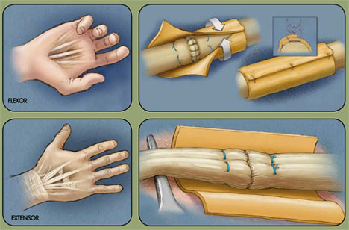
Picture 2.1 Tendon stitching and closure with amnion

Control group/ Group 2 underwent the same procedure. The difference was the amniotic membrane was not applied. On the tenth day, the animal was euthanized with Phenobarbital injection (100 mg/kg/iv). En block harvesting of tendon and surrounding soft tissue was taken from wound, parallel with both proximal stump of the tendon that was being sutured. It was put in a container and fixated with formalin 10%, then examined histopathologically. Fibroblast were measured using light microscope with 20x,100x,200x, and 400x magnification.

- RESULTS

There were several pictures samples that described fibroblast on rabbit’s tendon which were taken on the tenth day. Most of all had lesser and more organized fibroblast on tendon surface that were treated with freeze dried amnion in treatment group (t) compared with untreated control group (c). Fibroblast count were taken from 10 microscope visual fields for each tendon (Picture 3.1 – 3.10).

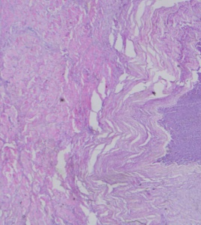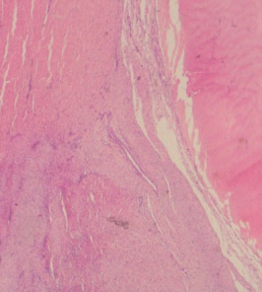
B
A
B
A
Picture 3.1 Fibroblast comparison, magnification 20x, HE staining, (A) Tendon connective tissue (B) Fibroblast

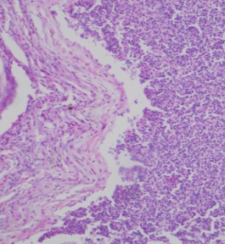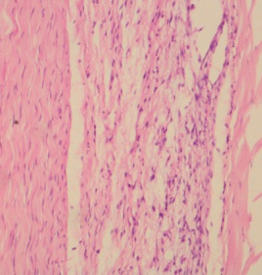
A
A
Picture 3.2 Fibroblast comparison, magnification 100x, HE staining (A) fibroblast

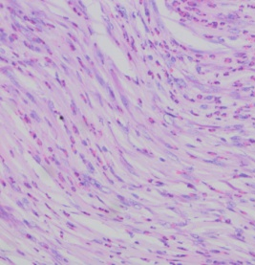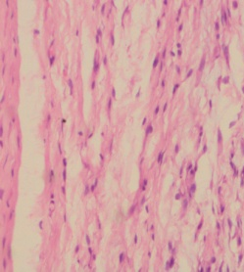
A
A
Picture 3.3 Fibroblast comparison, magnification 200x, HE staining (A) fibroblast

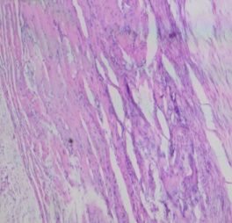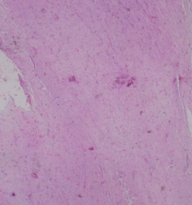
B
A
Picture 3.4 Tendon surface comparison, magnification 20x, HE staining, (A) Control (B) treatment
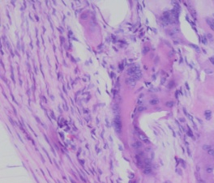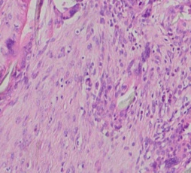
B
A
B
A
Picture 3.5 Comparison of tendon connective tissue (A) and fibroblast (B), HE staining.
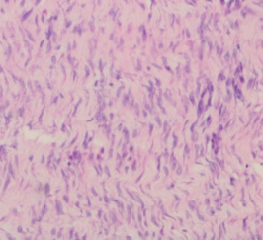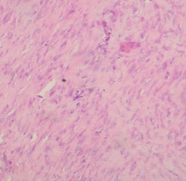
B
A
B
A
Picture 3.6 Comparison of tendon connective tissue (A) and fibroblast (B), magnification 100x, HE staining.
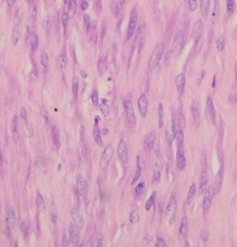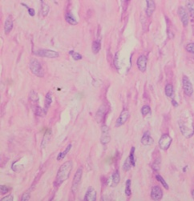
B
A
B
A
Picture 3.7 Comparison of tendon connective tissue (A) and fibroblast (B), magnification 400x, HE staining.
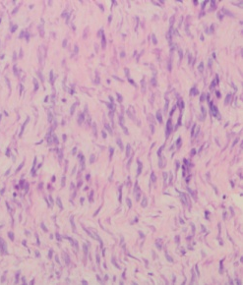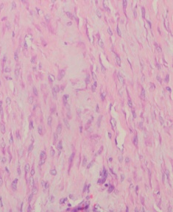
B
A
B
A
Picture 3.8 Comparison of tendon connective tissue (A) and fibroblast (B), magnification 200x, HE staining.
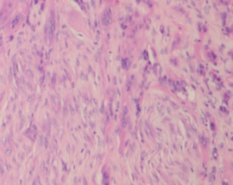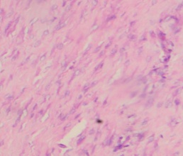
B
A
B
A
Picture 3.9 Comparison of tendon connective tissue (A) and fibroblast (B), magnification 100x, HE staining.

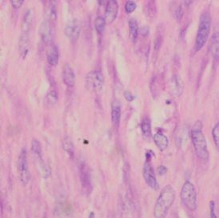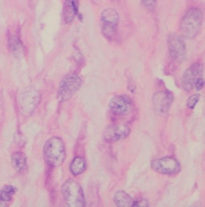
B
A
B
A
Picture 3.10 Comparison of tendon connective tissue (A) and fibroblast (B), magnification 400x, HE staining.

3.1 Analysis Statistics Chart

Each group was analysed using One-sample Kolmogorov-Smirnov test. The mean result of fibroblast in treatment group (t) was 112,7813.Control group (c) the mean of fibroblast was 145,8875. The difference between two groups was 33,1062 (statistically significant p<0,05). Both results were compared each other using t-test (Table 3.1.1).

Picture 3.3.1 Comparing the mean of fibroblast between treatment and control group

3.2 Fibroblast comparison mean chart

The chart below explains the comparison of mean fibroblast count between treatment group (red) and control group (green) with fibroblast count 112,7813 and 145,8875 respectively (Chart 3.2.1).

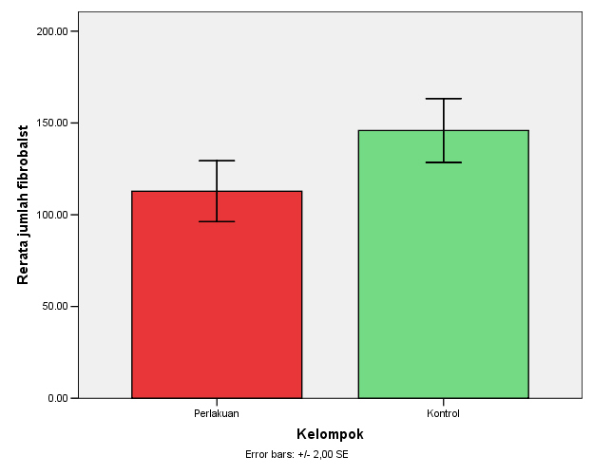
Chart 3.2.1 Comparison of mean fibroblast count between treatment group (red) and control group (green)

- DISCUSSION
Recent study indicated that application of freeze dried amnion on tendon injury had multiple function; as a biological scaffolding because of containing rich collagen, as an antiscarring by decreasing TGF-β transdifferentiation, it also containing mesenchymal stem cell and growth factor which promote faster wound healing³.
The difference mean of fibroblast count between the treatment group and control group were significant in this research (33,1062, p<0,05). It proved that freeze dried amnion could prevent adhesion in tendon healing process.
Some of the histological picture samples indicating that the surface of tendon in treatment group were more compact and organized compared with control group,it proved that amnion also had compact layer which contain collagen type I and type II. Those collagens were secreted by mesenchymal cells from fibroblast layer, that would maintain amnion mechanic integrity. Collagen type V and VI would make filamentous connection between interstitial collagen and basal membrane collagen⁴.
In this study, decreased fibroblast count on the tenth day in treatment group supports the theory of anti scar tissue effect by reducing transdifferentiation TGF-β hormone, which eventually could prevent tendon adhesion.

- CONCLUSION

This research showed that freeze dried amnion had big influence in preventing tendon adhesion by reducing fibroblast count through its biological functions due to its rich collagen containing, anti scarring effect by reducing transdifferentiation TGF-β hormone. The layer from freeze dried amnion also helping the tendon surface becoming more firm and organized. Freeze dried amnion also contains mesenchymal stem cells and growth factor that accellerate tendon healing.
Suggestions; further research to know the effect of freeze dried amnion on human tendon injury and to know the tensile strenght of the tendon that have received freeze dried amnion therapy.

REFERENCES

- Archauer, M.B. 1995. Tendon, in Plastic Surgery Indication Operation and Outcomes. Vol. Mosby. Toronto. p : 368-83.
- Harrison R. Hand Surgery-Tendon Healing Project. RAFT The Research. A UK Registered Charity No.299811; 2003 : 105-14.
- Ozgenet GY, Samli B, Ozcan M. Effect of Human Amniotic Fluid on Peritendinous Adhesion Formation and Tendon Healing After Flexor Tendon Surgery in Rabbits. J Hand Surgery 2001; 26A:2
- Colocho G, Graham WP, 1974Placental Physiology: Structure and Function of Fetomaternal Exchange. New York, Raven Press, 1983
- Bolt, P., Clerk A.N., Luu, H.H., et al. 2007. BMP-14 Gene Therapy Increases Tendon Tensile Strength in a Rat Model Achilles Tendon Injury. J Bone Joint Surg Am. p : 1315-20.
- Crues, L.R.1982. Tendon Structure Organization and Healing. in The Musculoskeletal Systerm Embryology Biochemistry and Physiology. Melbourne. p : 383-94.
- Carsteidt, C.A., Nordin, M. 1989. Biomechanics of Tendon and Ligament. in Basic Biomechanic of Musculoskeletal System. 2nd ed. Lea & Febiger Ltd. Philadhelphia. p : 59-70.
- Davidson JM, Benn SI, 1996. Regulation of angiogenesis and wound repair. In : Sisica ES, editor. Cellular and molecular pathogenesis. Philadelphia, Pensylvania : Lippincott-raven. p : 79-117

Eliasson, P., Andersson, T., Aspenberg, P, 2009. Rat Achilles Tendon Healing: mechanical loading and gene expression. J Appl Physiol. June 18. p : 399-407.
- Godbout, C., Ang, O., Jerome, F, 2006. Early Voluntary Exercise Does Not Promote Healing in a Rat Model Achilles Tendon Injury. J Appl Physiol. August 17.
- Green, D.P, 1993. Flexor Tendo Acute Injuries. in Operative Hand Surgery. 3rd ed. Churchill Livingstone. Tokyo. p : 1823-45.
- Gomez, M, 2004. The Physiology and biochemistry of soft tissue healing. In: Lin, T.W., Cardenas, L., Soslowsky, J. Biomechanic Tendon Injury and Repair. Journal of Biomechanics. Vol. 37. June. p : 865-77.
- Guler R, Uran N, Dilek FH, 1993. Comparative histopathological investigation of the effect of Lyophilized amniotic membrane on wound healing as an allograft material in rats. Journal of Islamic of Sciences vol. 6 no : 3
- Hatano I, Suga T, Diao E, Peimer CA, Howard C, 2000. Adhesion from flexor tendon injury: an animal study comparing surgical techniques. J Hand Surgery vol 25A. p : 252-60.
- HE qingyi, Chen Bingli, Wang Zhibiao, Li Qihong, 2002. Repair Flexor Tendon Defect of Rabbits with Complex of Fibroblast and Human Amnion Extracellular Matrix (HAECM). J. Chin Med 115. p : 542-545
- Lin, T.W., Cardenas, L., Soslowsky, 2004. Biomechanic Tendon Injury and Repair. Journal of Biomechanics. Vol. 37. June. p : 865-77.
- Montgomery, R.D, 1989. Healing of muscle ligament and tendon. Seminars in vetenary medicine and surgery (small animal). Vol 4. November. p : 304-11.
- Rockwood, C.A., Green, D.P., et al, 1996. Healing of the Musculoskeletal Tissues. in Fracture in Adults. Vol. 1. 4th ed. Lippincott-Raven. Philadelphia. p : 284-89.
- Sharma, P., Maffulli, N, 2005. Tendon Injury and Tendynopathy: Healing and Repair. J Bone Joint Surg Am. p : 187-202.
- Stricland JW. Flexor tendon-acute injury. In : Green DP, Hotchkiss RN, Pederson WC, editor, 1999. Green operative hand surgery. 4th ed.USA : Churchill Livingstone. p : 1851-83.

- Wheeless III CR. 2009. Flexor tendon repair techniques: core suture techniques. A p r i l 2 6 .

